Ex. No. 2 | Working with HTML5 Form and Media Elements
Date of Exercise | 24 July 2026
GitHub Host Link | https://jinto-joseph.github.io/WEB_TECH_LAB/24_July_Exp_2/exercise1.html

Aim
To design and develop a responsive webpage using HTML5 form controls, multimedia elements (<audio>, <video>), structural grouping elements (<fieldset>, <legend>), progress bars, and embedded frames (<iframe>).
Description
HTML Form Elements
All forms start with the <FORM> tag and end with </FORM>. All other form objects go between these two tags.
The form tag has two main properties: METHOD and ACTION.
<form action="/action_page.php" method="get"> </form>
The `<form>` element can contain one or more of the following form elements:
- <input>
- <textarea>
- <button>
- <select>
- <option>
- <fieldset>
- <label>

The `<input>` tag specifies an input field where the user can enter data. `<input>` elements are used within a `<form>` element to declare input controls that allow users to input data. An input field can vary in many ways, depending on the `type` attribute.
<form action="/action_page.php" method="get">
First name: <input type="text" name="fname"><br>
Last name: <input type="text" name="lname"><br>
<input type="submit" value="Submit">
</form>

Input Types:
Here are the different input types you can use in HTML
<input type="button">
<input type="checkbox">
<input type="date">
<input type="datetime-local">
<input type="email">
<input type="file">
<input type="hidden">
<input type="image">
<input type="month">
<input type="number">
<input type="password">
<input type="radio">
<input type="range">
<input type="reset">
<input type="search">
<input type="submit">
<input type="tel">
<input type="text">
<input type="time">
<input type="url">
<input type="week">

Textarea Element
The `<textarea>` tag defines a multi-line text input control. A text area can hold an unlimited number of characters, and the text renders in a fixed-width font (usually Courier). The size of a text area can be specified by the `cols` and `rows` attributes, or even better; through CSS' `height` and `width` properties.
<textarea rows="4" cols="50">
</textarea>
Select Element
The `<select>` element is used to create a drop-down list. The `<option>` tags inside the `<select>` element define the available options in the list.
<select>
<option value="volvo">Volvo</option>
<option value="saab">Saab</option>
<option value="mercedes">Mercedes</option>
<option value="audi">Audi</option>
</select>
Fieldset Element
The `<fieldset>` tag is used to group related elements in a form. The `<fieldset>` tag draws a box around the related elements.
<form>
<fieldset>
<legend>Personalia:</legend>
Name: <input type="text"><br>
Email: <input type="text"><br>
Date of birth: <input type="text">
</fieldset>
</form>
Media Elements:
The following are the most popular media elements.
- audio:
Audio element is used for defining or creating a music element in your simple HTML page.
<audio controls>
<source src="1.mp3" type="audio/mpeg">
</audio>
- video:
The Video element creates a video element in your HTML page.
<video controls>
<source src="1.mp4" type="video/mp4">
</video>
- embed:
It is also called a container because as the name suggests it is used for defining containers for the external applications or we can say plug-ins for the applications.
<embed src="1.swf">

Program:
<!DOCTYPE html>
<html lang="en">
<head>
<meta charset="UTF-8">
<meta name="viewport" content="width=device-width, initial-scale=1.0">
<title>Ex.No: 02 - Working with HTML5 Form and Media Elements</title>
<style>
:root {
--primary-color: #2b5797;
--border-color: #cccccc;
--bg-light: #f9f9f9;
--text-color: #333333;
}

* {
box-sizing: border-box;
margin: 0;
padding: 0;
}

body {
font-family: Arial, Helvetica, sans-serif;
background-color: #f4f6f8;
color: var(--text-color);
padding: 20px;
display: flex;
justify-content: center;
}

.wrapper {
width: 100%;
max-width: 960px;
background-color: #ffffff;
border: 1px solid #b5b5b5;
padding: 20px;
box-shadow: 0 4px 10px rgba(0, 0, 0, 0.1);
display: flex;
flex-direction: column;
gap: 20px;
}

.header {
display: flex;
justify-content: space-between;
align-items: center;
padding-bottom: 15px;
border-bottom: 1px solid var(--border-color);
}

.profile-img {
width: 120px;
height: 140px;
object-fit: cover;
border: 1px solid var(--border-color);
border-radius: 4px;
}

.header h1 {
font-size: 26px;
color: #111111;
font-weight: bold;
}

.navbar {
display: flex;
justify-content: space-between;
align-items: center;
padding: 10px 0;
border-bottom: 1px solid var(--border-color);
}

.nav-links {
display: flex;
gap: 40px;
}

.nav-links a {
color: #551a8b;
text-decoration: underline;
font-weight: bold;
font-size: 15px;
}

.search-box input[type="search"] {
padding: 4px 8px;
border: 1px solid #aaa;
border-radius: 2px;
}

.grid-top {
display: grid;
grid-template-columns: 240px 1fr;
gap: 20px;
align-items: start;
}

.skills-list {
display: flex;
flex-direction: column;
gap: 14px;
}

.skill-item label {
display: block;
font-weight: bold;
font-size: 13px;
margin-bottom: 4px;
}

progress {
width: 100%;
height: 18px;
appearance: none;
-webkit-appearance: none;
-moz-appearance: none;
border: 1px solid #777777;
border-radius: 3px;
background-color: #e0e0e0;
overflow: hidden;
display: block;
}

progress::-webkit-progress-bar {
background-color: #e0e0e0;
border-radius: 3px;
}

progress::-webkit-progress-value {
background: linear-gradient(180deg, #62c462 0%, #468847 100%);
border-radius: 2px;
}

progress::-moz-progress-bar {
background: linear-gradient(180deg, #62c462 0%, #468847 100%);
border-radius: 2px;
}

.media-container {
display: flex;
flex-direction: column;
gap: 10px;
}

video {
width: 100%;
height: 220px;
border: 1px solid #ccc;
background-color: #000000;
border-radius: 4px;
object-fit: contain;
}

audio {
width: 100%;
margin-top: 5px;
}

.form-grid {
display: grid;
grid-template-columns: 1fr 1fr;
gap: 20px;
}

fieldset {
border: 1px solid #999999;
padding: 15px;
border-radius: 2px;
background-color: #ffffff;
}

legend {
font-weight: bold;
padding: 0 6px;
color: #222222;
font-size: 14px;
}

.form-group {
display: flex;
align-items: center;
margin-bottom: 12px;
font-size: 13px;
}

.form-group label {
width: 120px;
font-weight: normal;
color: #222222;
}

.form-group input[type="text"],
.form-group input[type="password"],
.form-group input[type="number"],
.form-group input[type="tel"],
.form-group input[type="email"],
.form-group input[type="url"],
.form-group input[type="date"],
.form-group select,
.form-group textarea {
flex: 1;
padding: 4px 6px;
border: 1px solid #767676;
border-radius: 2px;
font-size: 13px;
}

.required-star {
color: black;
margin-left: 4px;
font-weight: bold;
}

.radio-group {
display: flex;
gap: 15px;
align-items: center;
}

.submit-btn {
background-color: #e1e1e1;
border: 1px solid #767676;
padding: 4px 16px;
cursor: pointer;
border-radius: 2px;
font-size: 13px;
}

.submit-btn:hover {
background-color: #d0d0d0;
}

.bottom-grid {
display: grid;
grid-template-columns: 1fr 1fr;
gap: 20px;
}

.embed-box, .iframe-box {
border: 1px solid #ccc;
height: 320px;
overflow: hidden;
border-radius: 4px;
background-color: #ffffff;
}

iframe, embed {
width: 100%;
height: 100%;
border: none;
}

.footer {
border-top: 1px solid var(--border-color);
padding-top: 15px;
font-size: 13px;
color: #333333;
}

.footer p {
margin-bottom: 4px;
}
</style>
</head>
<body>

<!-- HTML Comment Tag Requirement -->
<div class="wrapper">

<header class="header">
<img src="profile.jpg" onerror="this.src='https://encrypted-tbn0.gstatic.com/images?q=tbn:ANd9GcRrnoeCDSTNv_vdY7dQ3yRL9g0bGCq9ZsTFWUiki63hrQ&s'" alt="Mr. Jinto Joseph Profile Photo" class="profile-img">
<h1>Mr.Jinto Joseph</h1>
</header>

<nav class="navbar">
<div class="nav-links">
<a href="#academics">Academics</a>
<a href="#achievements">Achievements</a>
<a href="#friends">Friends</a>
</div>
<div class="search-box">
<input type="search" placeholder="search...">
</div>
</nav>

<section class="grid-top">
<div class="skills-list">
<div class="skill-item">
<label for="photoshop">Photoshop:</label>
<progress id="photoshop" value="70" max="100">70%</progress>
</div>
<div class="skill-item">
<label for="java">Java:</label>
<progress id="java" value="85" max="100">85%</progress>
</div>
<div class="skill-item">
<label for="cpp">C++:</label>
<progress id="cpp" value="90" max="100">90%</progress>
</div>
<div class="skill-item">
<label for="php">PHP:</label>
<progress id="php" value="60" max="100">60%</progress>
</div>
<div class="skill-item">
<label for="javascript">Javascript:</label>
<progress id="javascript" value="80" max="100">80%</progress>
</div>
</div>

<div class="media-container">
<video controls style="width: 100%; height: 220px; border: 1px solid #ccc; border-radius: 4px; background: #000; object-fit: contain;">
<source src="video.mp4" type="video/mp4">
<source src="https://www.w3schools.com/html/mov_bbb.mp4" type="video/mp4">
Your browser does not support the video tag.
</video>

<audio controls style="width: 100%; margin-top: 4px;">
<source src="https://www.soundhelix.com/examples/mp3/SoundHelix-Song-1.mp3" type="audio/mpeg">
Your browser does not support the audio element.
</audio>
</div>
</section>

<form action="#" method="get">
<div class="form-grid">

<fieldset>
<legend>Personal Information</legend>

<div class="form-group">
<label for="username">User name:</label>
<input type="text" id="username" name="username" placeholder="Enter the user name">
<span class="required-star">*</span>
</div>

<div class="form-group">
<label for="password">Password:</label>
<input type="password" id="password" name="password" value="Madangs-10">
<span class="required-star">*</span>
</div>

<div class="form-group">
<label for="regno">Reg No:</label>
<input type="text" id="regno" name="regno" value="URK24CS1210">
<span class="required-star">*</span>
</div>

<div class="form-group">
<label for="age">Age:</label>
<select id="age" name="age">
<option value="19-24" selected>19-24</option>
<option value="18">18</option>
<option value="25+">25+</option>
</select>
</div>

<div class="form-group">
<label>Gender:</label>
<div class="radio-group">
<label style="width:auto;"><input type="radio" name="gender" value="Male"> Male</label>
<label style="width:auto;"><input type="radio" name="gender" value="Female" checked> Female</label>
</div>
</div>

<div class="form-group">
<label for="dob">DOB:</label>
<input type="date" id="dob" name="dob" value="2005-07-17">
<span class="required-star">*</span>
</div>

<div class="form-group">
<label for="favcolor">Favorite Color:</label>
<input type="color" id="favcolor" name="favcolor" value="#e6f2ff">
</div>

<div class="form-group">
<label for="profile_photo">Change Profile Photo:</label>
<input type="file" id="profile_photo" name="profile_photo">
</div>
</fieldset>

<fieldset>
<legend>Contact Information</legend>

<div class="form-group" style="align-items: flex-start;">
<label for="address" style="margin-top: 4px;">Address:</label>
<textarea id="address" name="address" rows="3" placeholder="Your address"></textarea>
</div>

<div class="form-group">
<label for="state">State:</label>
<select id="state" name="state">
<option value="">Select</option>
<option value="Tamil Nadu">Tamil Nadu</option>
<option value="Kerala">Kerala</option>
<option value="Karnataka">Karnataka</option>
</select>
<span class="required-star">*</span>
</div>

<div class="form-group">
<label for="zipcode">Zipcode:</label>
<input type="number" id="zipcode" name="zipcode" placeholder="only 6 numbers">
<span class="required-star">*</span>
</div>

<div class="form-group">
<label for="mobile">Mobile:</label>
<input type="tel" id="mobile" name="mobile" placeholder="(+91)99999-99999">
</div>

<div class="form-group">
<label for="email">Email:</label>
<input type="email" id="email" name="email" placeholder="valid email">
<span class="required-star">*</span>
</div>

<div class="form-group">
<label for="url">URL:</label>
<input type="url" id="url" name="url" placeholder="valid url">
<span class="required-star">*</span>
</div>

<div class="form-group">
<input type="checkbox" id="iverified" name="iverified" checked style="margin-right: 8px;">
<label for="iverified" style="width: auto;">I verified</label>
</div>

<div class="form-group" style="margin-bottom: 0;">
<input type="submit" value="Submit" class="submit-btn">
</div>
</fieldset>

</div>
</form>

<section class="bottom-grid">
<div class="embed-box">
<embed src="Ex2.pdf" type="application/pdf" width="100%" height="100%">
</div>

<div class="iframe-box">
<iframe src="https://maps.google.com/maps?q=Karunya%20University,%20Coimbatore,%20Tamil%20Nadu&t=&z=13&ie=UTF8&iwloc=&output=embed" loading="lazy" title="Karunya University Location Map"></iframe>
</div>
</section>

<footer class="footer">
<p><strong>Your address</strong></p>
<p>© 2026. URK24CS1210 - Web Technology Lab Batch 1. All Rights Reserved.</p>
</footer>

</div>

</body>
</html>

Output:
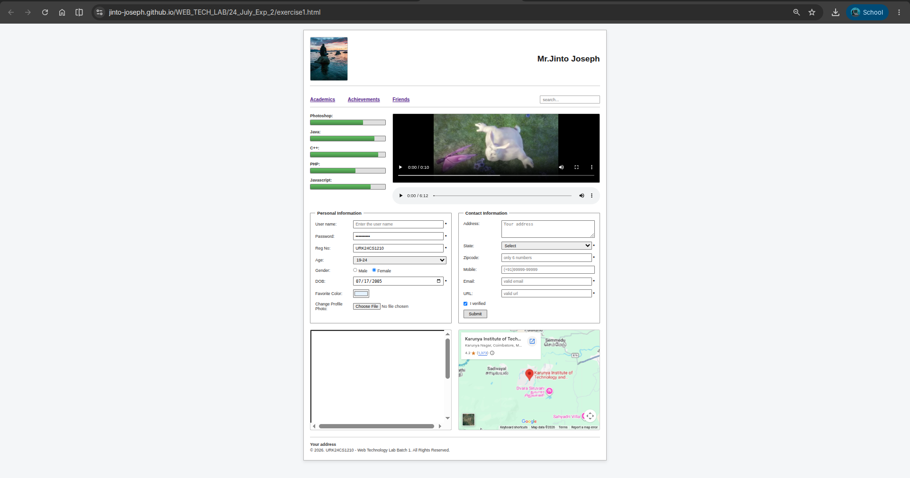

Result:
The HTML5 webpage featuring form controls, media elements (<audio>, <video>), embedded frames (<iframe>), and skill progress bars was successfully designed, implemented, and verified according to the lab layout requirements.

